**Abueva, Napoleon V. (1930-)**

National Artist Napoleon Abueva is pioneer of modernism in sculpture. He trained at the University of the Philippines School of Fine Arts, mentored by Guillermo Tolentino, whose classical style placed him alongside the forerunners of conservatism in Philippine art at the turn-of-the century. The modernist vein in Philippine art can be characterized as having increased emphasis on the formal aspects of design, expressiveness, the depiction of the unsightly, the shift from urban to rural subjects, the exploration of genre themes, and a heightened awareness of national identity and its manifestations in art. These were greatly evident in Abueva’s early works which exhibited his versatility, the expanse of his interest in varied themes and subject matter, his skillful manipulation of material as conveyed through form rendered in varying degrees of complexity. His works encompass a panorama of themes and styles and by turns, can be classified as figurative, constructivist or abstract. They may appear minimalist in silhouette and composition such as his *Allegorical Harpoon* (1964), figurative like his many commissioned works for institutions such as those in the University of the Philippines campuses or stylized and functional as the furniture and house parts he designed and made.

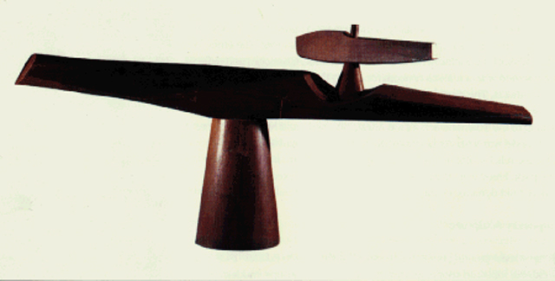

Napoleon Abueva, *Allegorical Harpoon*, 1964, wood carving, Cultural Centre Philippines. Copyright to be sought from Cris B. Millado, CCP Artistic Director and Vice President.

Abueva was born in the Visayan island of Bohol. He had his first lessons in sculpture under Fidel Araneta. By way of a Fullbright scholarship, he furthered his fine arts training at Cranbrook Academy in Michigan. He then studied ceramics and sculpture at the University of Kansas, and took courses at Harvard University in the mid-1950s.

Abueva approaches questions of functionality by posing them as sculptural problems, and in the process makes pieces that are highly individual, appealing to sight and touch, and mobilizing to great degree the voluble qualities of material and scale in three-dimensional expressions. His works best convey a combination of the supple and firm, the organic and synthetic, the natural and manufactured, of permanence and dynamism, the flights of fancy tempered by his firm attachment to his roots.

Napoleon Abueva’s major works include *Moses* (1951), a buoyant sculpture that floats on water; *Rice Planting* an early modernist piece from 1952 and *Allegorical* *Harpoon* sculpted from Molave a Philippine hardwood. The latter was the country’s entry to the 1964 Venice Biennale. Other notable pieces are the bronze *Water Buffalo* of 1968, *Birds* in veined marble from 1971, and *Alabaster City* of 1973. He has also done large scale commissioned works. Most prominent are the *Transfiguration* of 1979, at the Eternal Gardens Memorial Park in Caloocan, Metro Manila and *the Fourteen Stations of the Cross* in hardwood at the Claret School Chapel in Quezon City. He has numerous commissioned pieces abroad and in the Philippines, many of them recognized through awards from competitions and his countless contributions to the development of Philippine art and culture. At 46, he was the youngest sculptor to be conferred the National Artist Award.

Napoleon Abueva taught for a lengthy period and served as dean of the University of the Philippines College of Fine Arts and mentored an entire generation of Filipino artists.

**References and further reading:**

Abueva, Napoleon V. (1990) *Murmurings of a Wood, Stone and Metal Carver*. Manila: Filways Printing.

Aguilar, Marlene and Bortles, Larry. (1999) *Fine Artists of the Philippines*. Quezon City: Jacoby Publishing House.

Almario, Virgilio, Almario, Emelina and Cuyugan, Cristina, eds. (1991) *Sculptors in Filway’s Philippine Almanac.* Makati City: Filway Marketing.

Benesa, Leonidas. (1969) *The Art of Napoleon Abueva, Sculptor*. Manila: Philippine Art Series.

Bondoc, Salome ed. (2006) *Sculptors in The New Philippine Almanac*. Hong Kong: Encleare Foundation, 19-20.

Capili, Jose Wendell P. (2001) ‘Interview with National Artist for Sculpture Napoleon Abueva.’ *Bulawan: Journal of Philippine Arts and Culture,* issue 1, Intramuros: NCCA. p. 58-63.

Cultural Center of the Philippines. (1998) *The National Artists of the Philippines*. Pasay City: Cultural Center of the Philippines, 2-13.

Guillermo, Alice G. (1994) ‘Napoleon V. Abueva.’ In the *Cultural Center of the Philippines Encyclopedia of Philippine Art*, Volume ---, 301. Pasay City: Cultural Center of the Philippines.

Hofilena, Ramon H. 1979. *Abueva*. Silay City: Silay City Tourism Board.

Sering, Tara FT. 2009. “A Place in the Sun: National artist Napoleon Abueva revisits his iconic “sunburst”, a large blazing sun sculpture that has been the centerpiece of the Peninsula Manila lobby for 15 years”, in *Contemporary Art Philippines*, issue 4. p. 28-29.

**Video Recording**

Medina, Susan Calo, producer/host and Quintos, Floy, Scriptwriter. *“To Sculpt a Life…Abueva, an Intimate View”*. National Commission for Culture and the Arts. Manila: Travel Time, 1997.

**Virtual Sources on Works in Public Collections**

<http://www.nationalmuseum.gov.ph/nationalmuseumbeta/Collections/Mother.html>

(Mother and Child, c. 1960s)

<http://www.metmuseum.ph/ongoingexhibitions.php#ABUEVA>

(January 2014 Retrospective at the Metropolitan Museum Manila, exhibition catalogue can be accessed from site)

<http://plotpublicart.wordpress.com/tag/napoleon-abueva/>

(Tribute to the Filipino Entrepreneur)

<http://www.upv.edu.ph/upv/index.php/diwata-ng-dagat>

(Diwata ng Dagat, University of the Philippines Visayas)

<http://plotpublicart.wordpress.com/2013/02/22/napoleon-abuevas-fredeswinda/>

(Fredeswinda, current state)

<http://www.ph.net/htdocs/education/sculp.htm>

(Allegorical Harpoon, Fredeswinda)

<http://www.aaa.org.hk/Collection/Details/25428>

(Paul Zafaralla, Napoleon Abueva: Father of Philippine Modern Sculpture)